Homework 6

AE_5830 Dr. Hosder

Matt Pahayo

2021

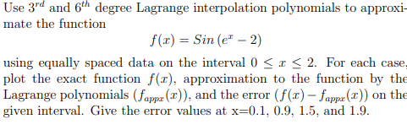

**Results**

Q1:

**Table 1 Error of at specific values per degree of polynomial**



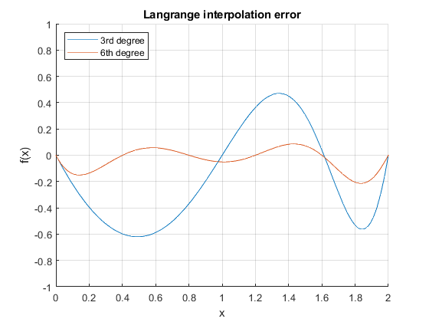

**Figure 1 Absolute Error plot**

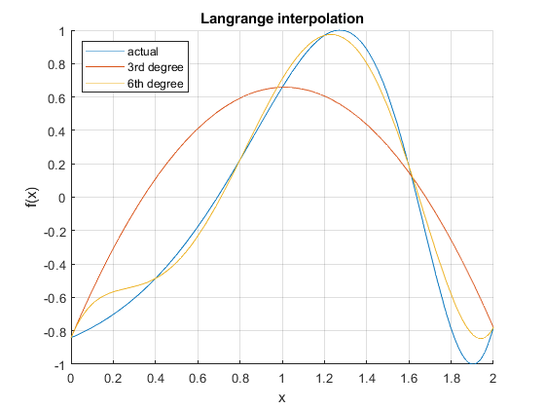

**Figure 2 plot of approximations and function**

1. 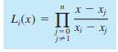
2. 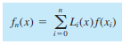
3. n =3 and 6

Q2:

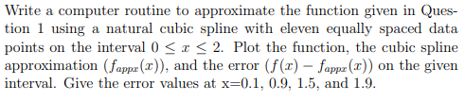

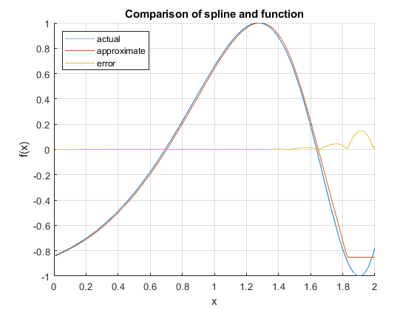

**Figure 3 Q2 plot**



1. Find coeffcients by solving a linear system for a natural cubic spline
2. Plug back into cubic spline quation

Q3:

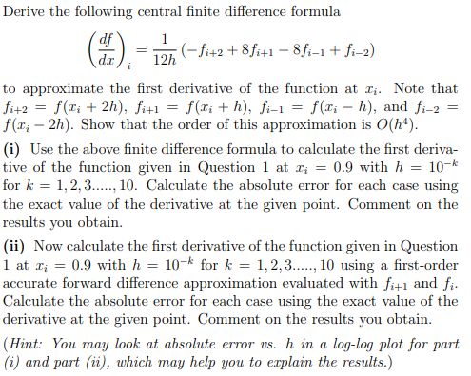

**Derivation of the formula above will be given Appendix A.**

1. 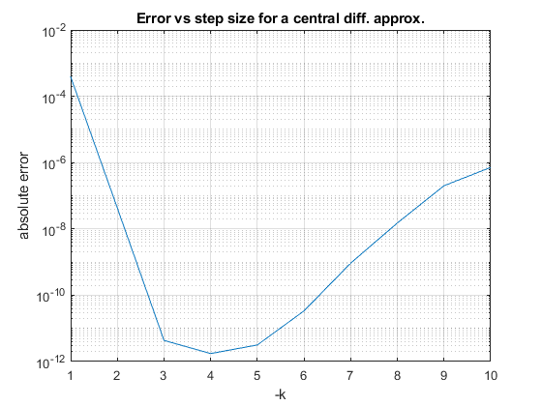

The step size reduces the error to a point, and then rises back up because the truncation error is overshadowed by the round-off error.

**Tabulated derivatives and errors per method at a given step size x = 0.9**



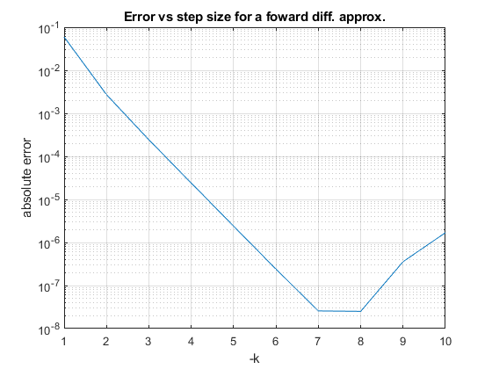

A forward difference approximation behaves like the central difference method in that they reduce the error to some value of the step size but decreasing the step size increases the round-off error. The Central difference method is more accurate but requires more computing power.

Q4:

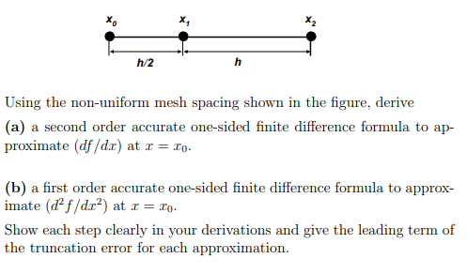

a)

$${f_{i}}^{'}=\frac{f_{i+1}-f_{i}}{h}*\frac{f_{i+2}-f_{i+1}+2f_{i}}{8h}-\frac{13h^{2}}{192}{f_{i}}^{'''}$$

b)

$${f_{i}}^{''}=\frac{f_{i+2}-{3f}_{i+1}-f_{i}}{h^{2}}-\frac{13h}{24}{f_{i}}^{'''}$$

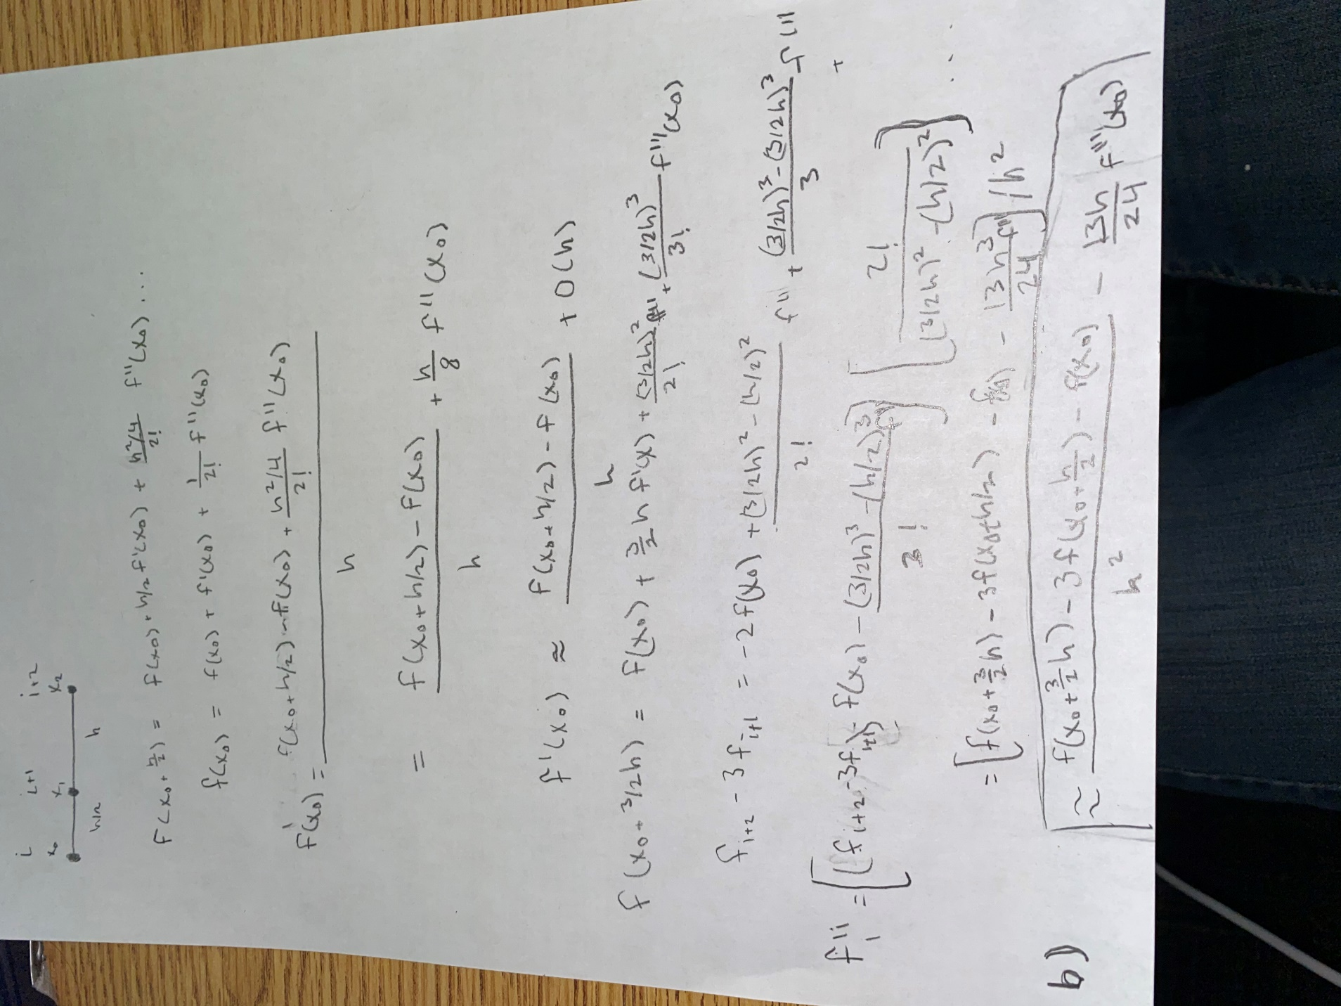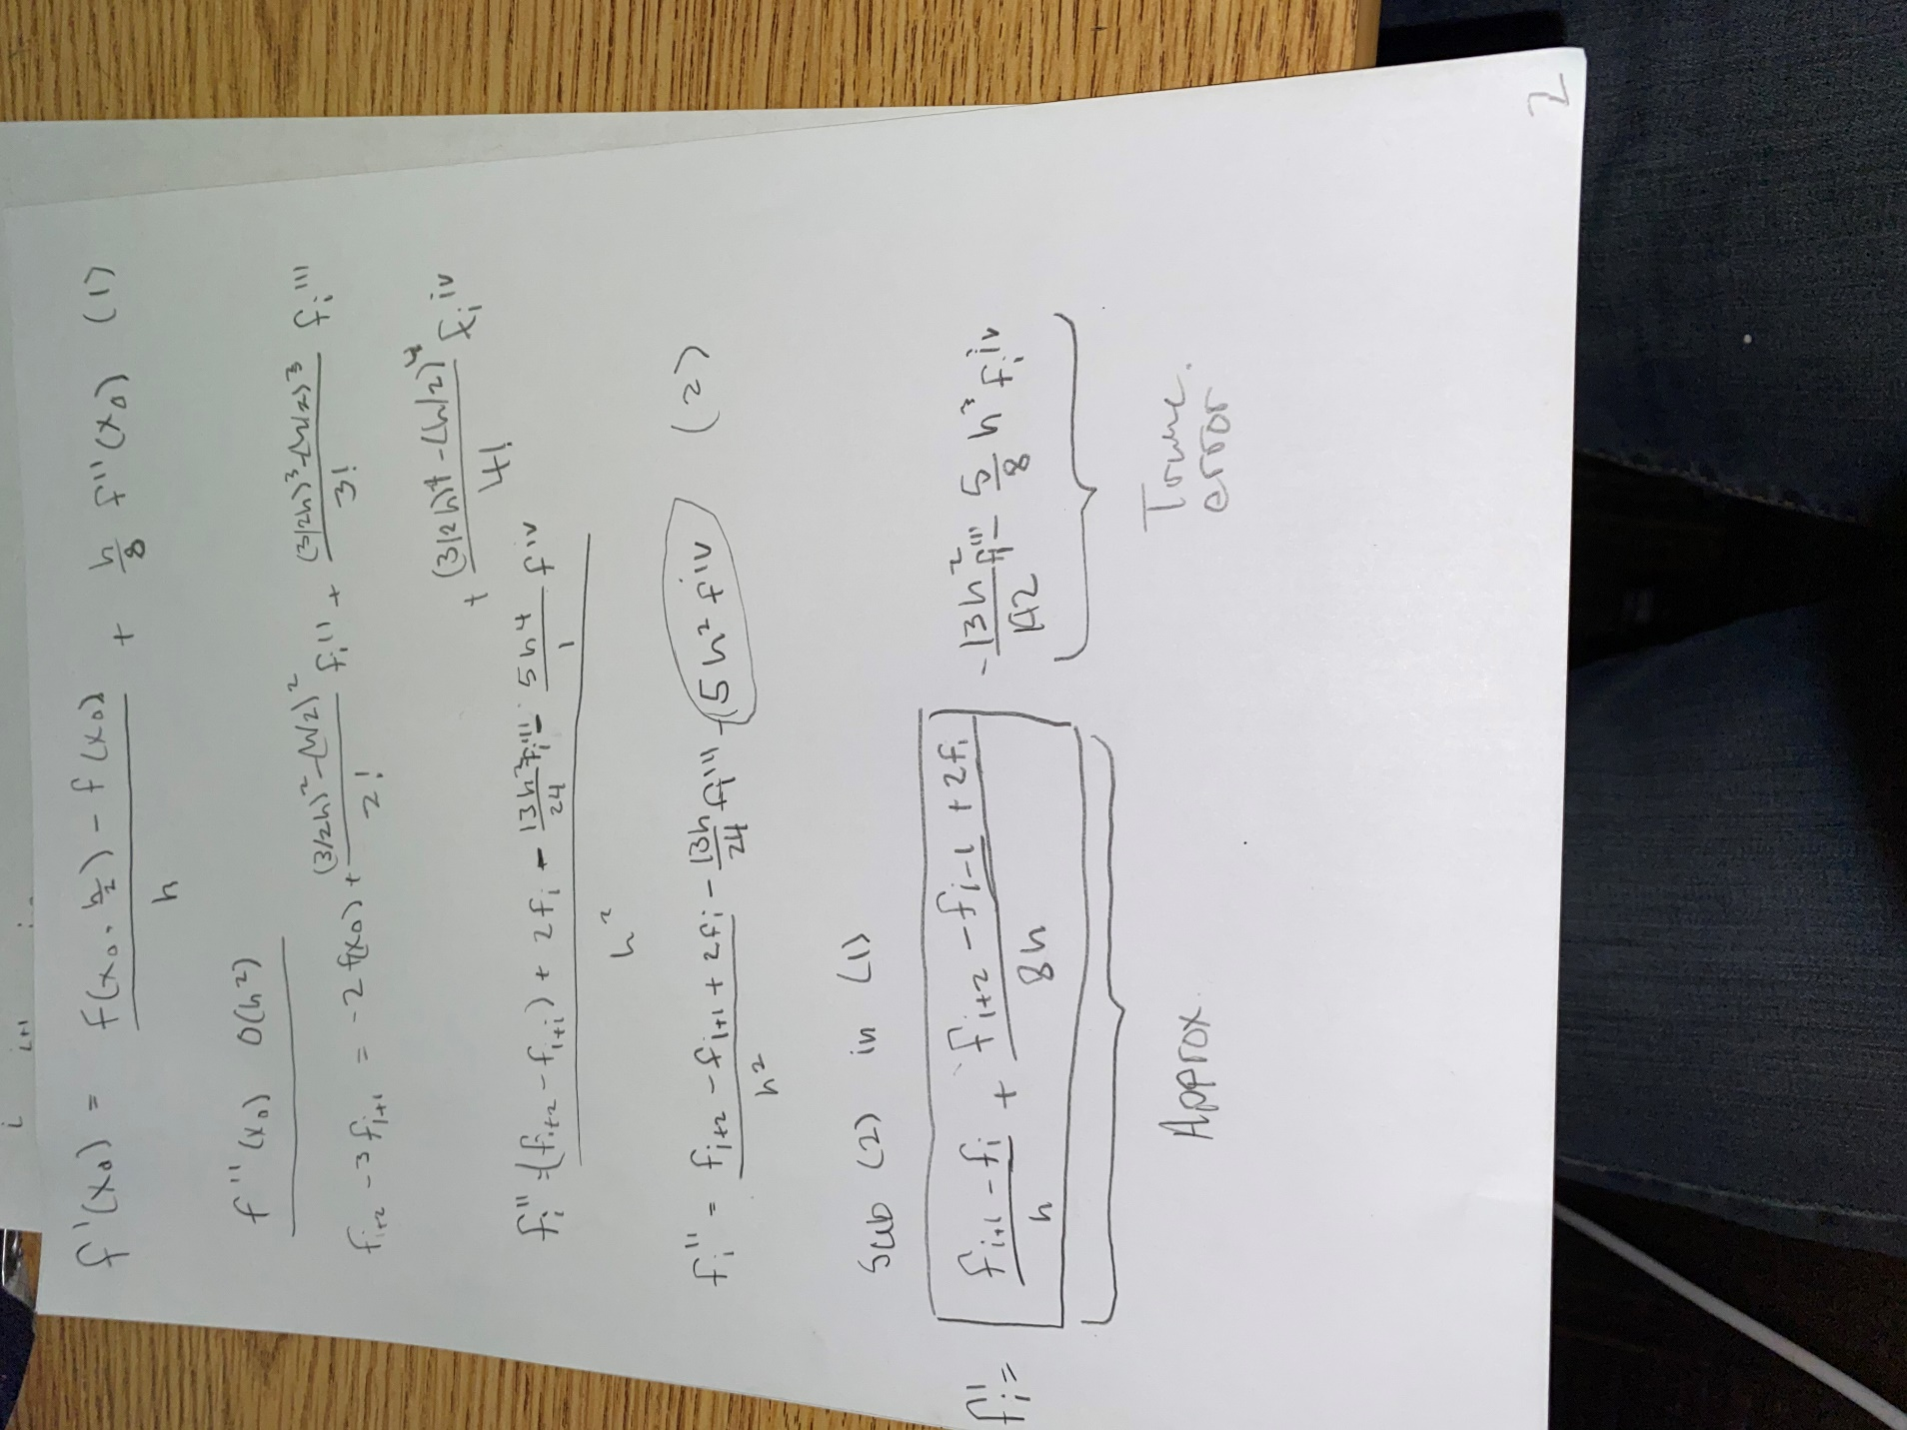

**Appendix A – q3 derivation**

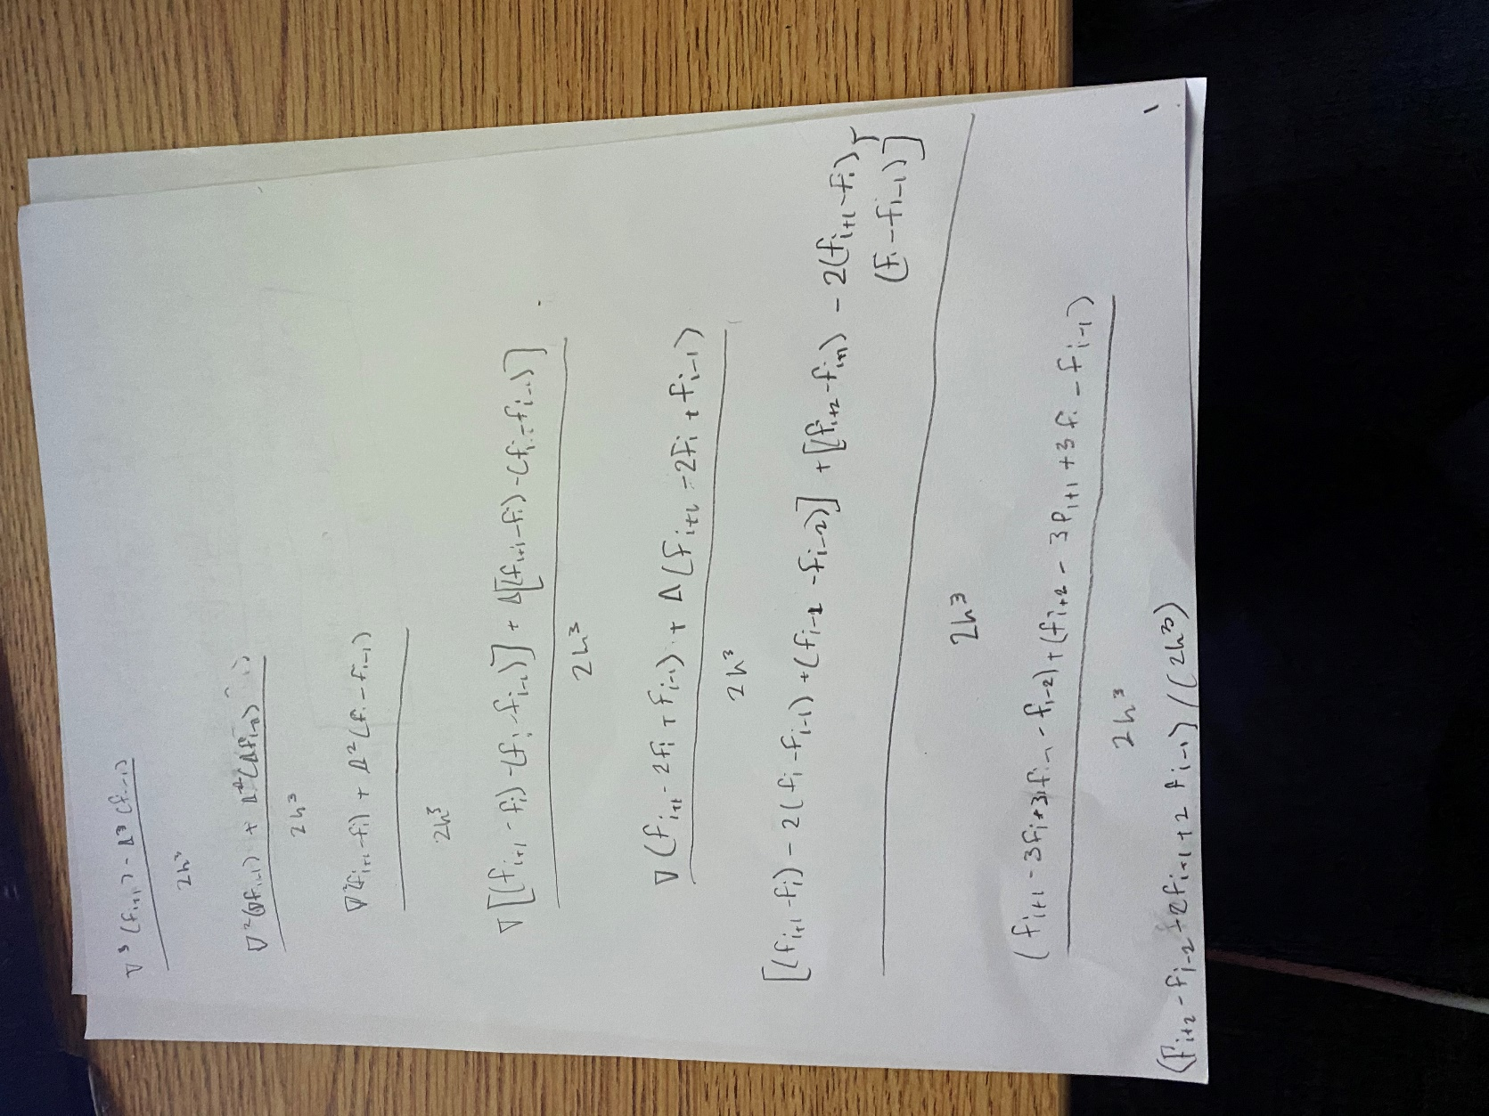

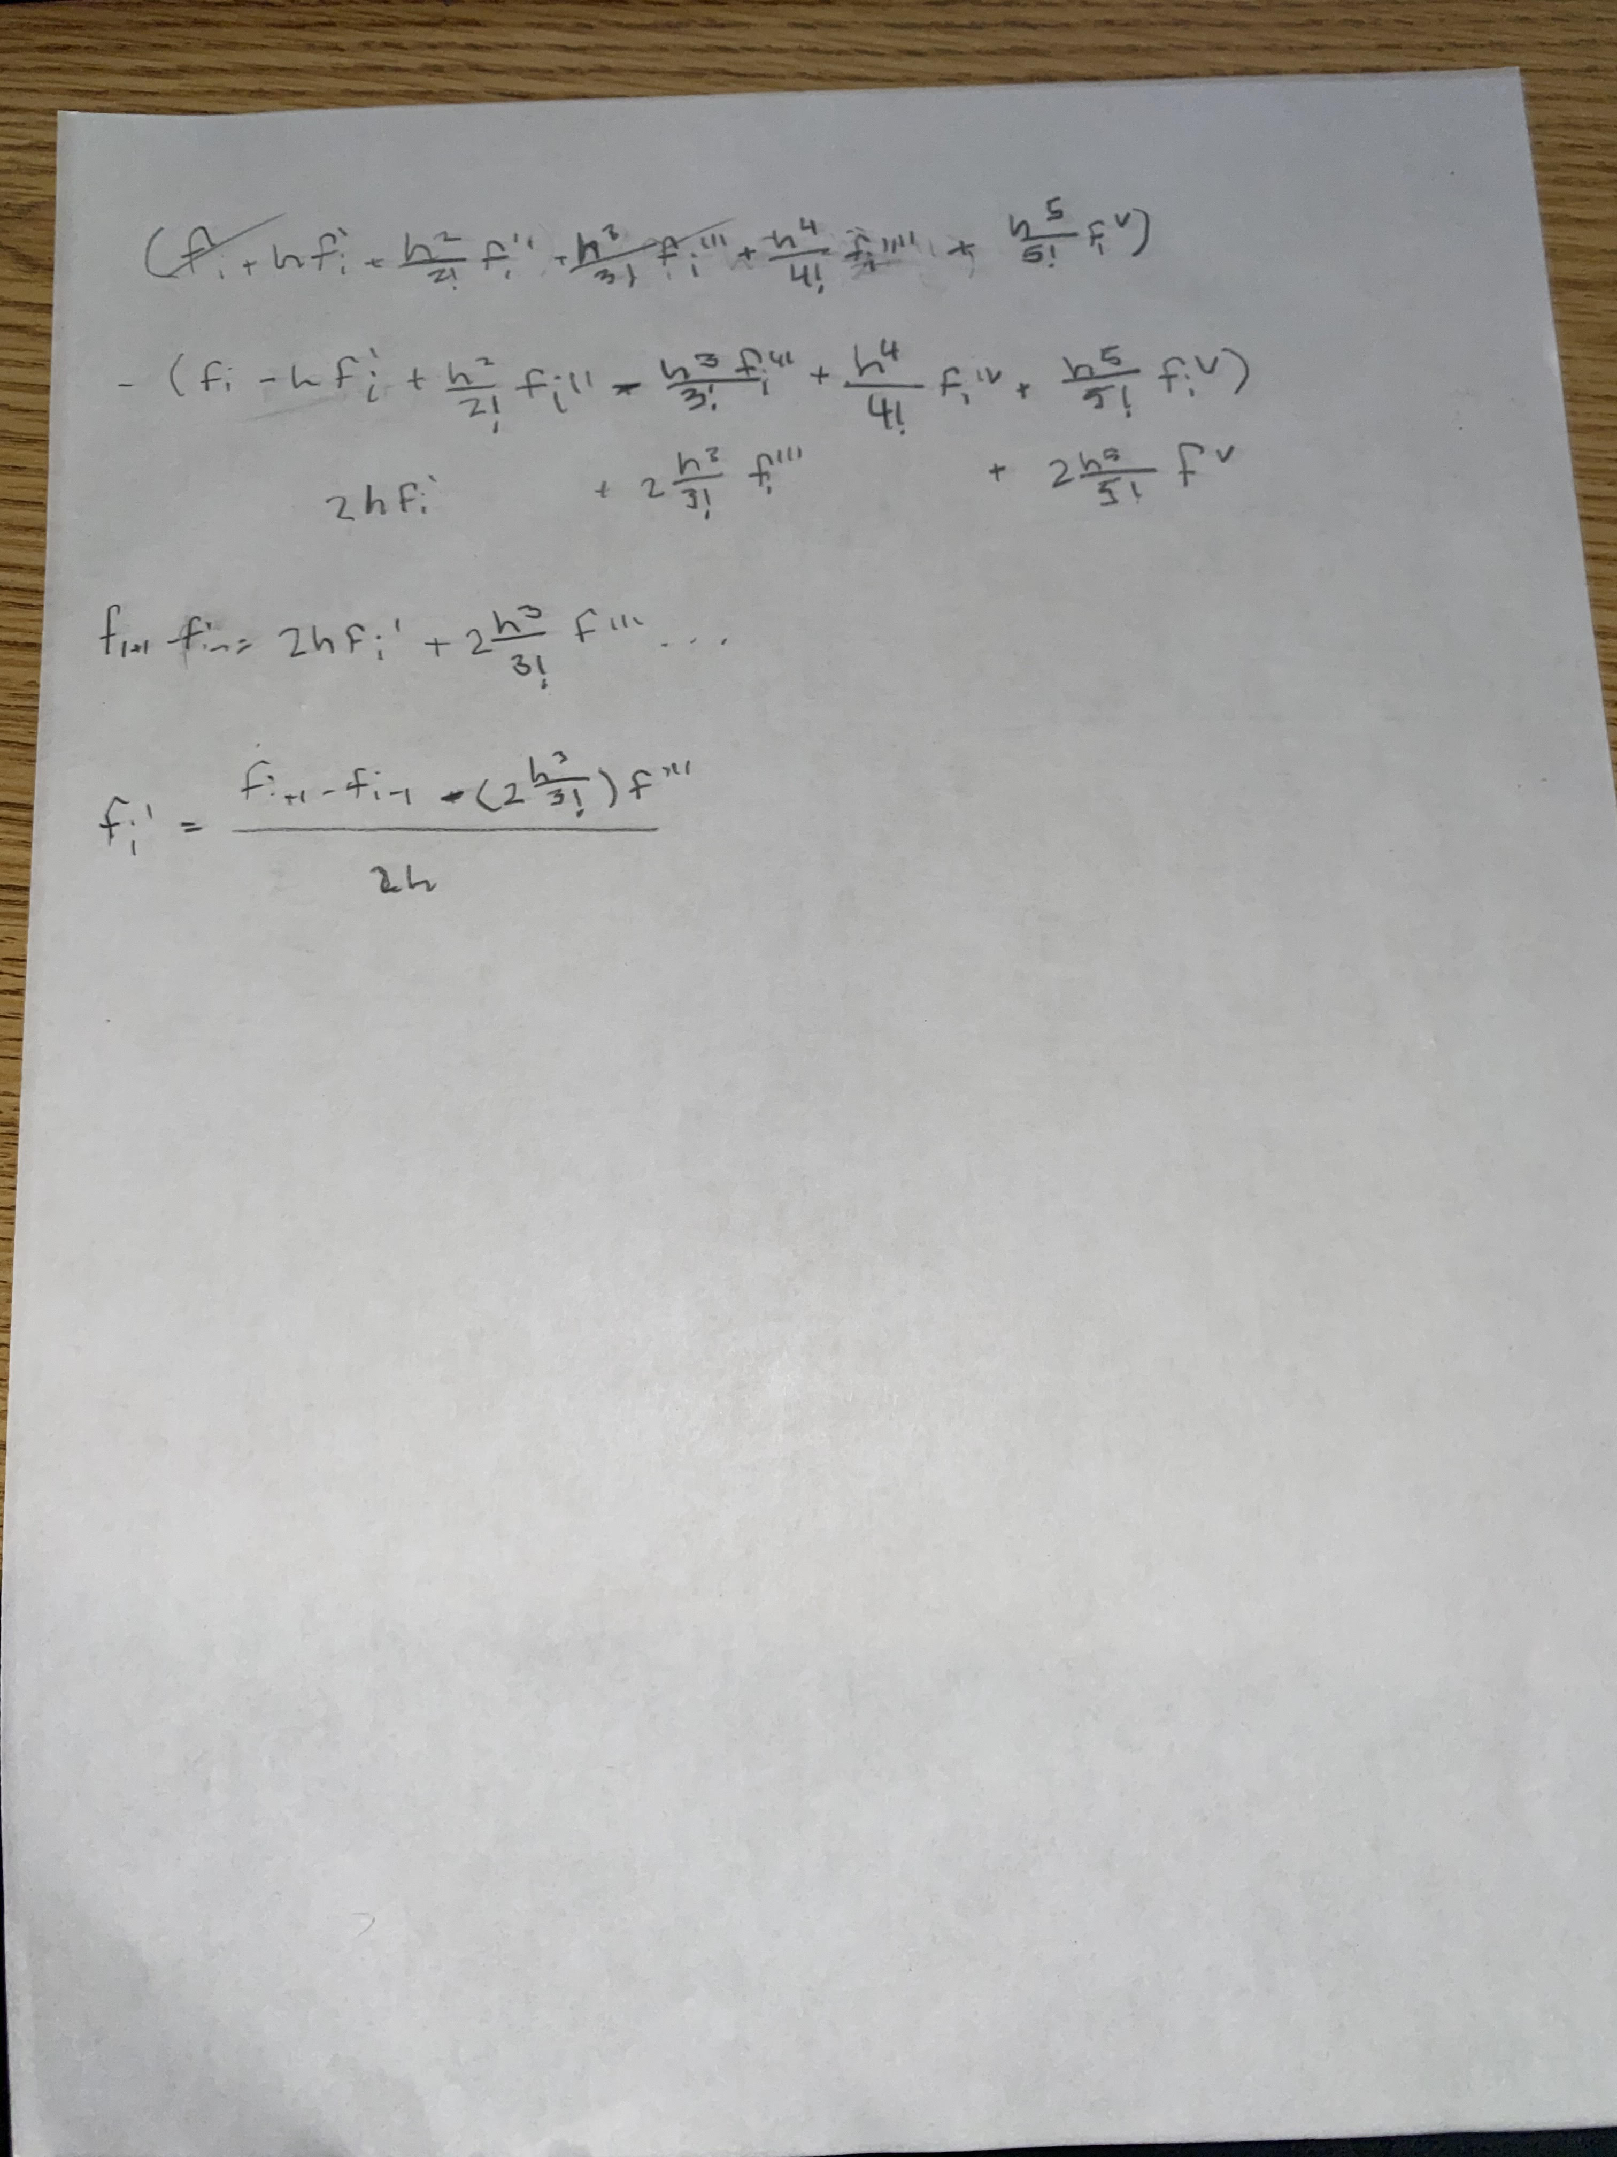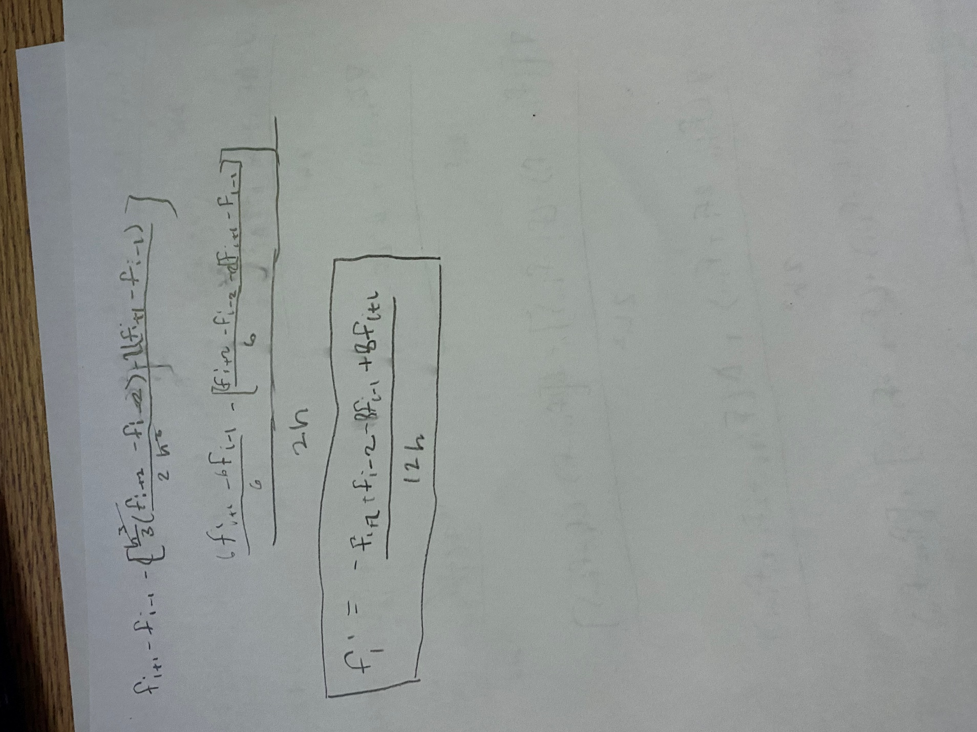

**Appendix B – code**

% main.m

clc

clear all

close all

format longg

%=========================================================================%

% q1

%=========================================================================%

syms xx

interval = 2;

x = transpose(0:2/interval:2);

f = @(x) sin(exp(x)-2);

y = f(x);

n = interval;

fapprox3(xx) = Lagran(x,y,n,xx);

interval = 5;

x = transpose(0:2/interval:2);

y = f(x);

n = interval;

fapprox6(xx) = Lagran(x,y,n,xx);

figure(1);

hold on

fplot(f)

fplot(fapprox3)

fplot(fapprox6)

xlim([ 0 2 ])

ylim([-1 1])

title('Langrange interpolation')

xlabel('x')

ylabel('f(x)')

legend('actual','3rd degree','6th degree','Location','northwest')

grid on

hold off

x = [.1;.9;1.5;1.9];

err3 = double(f(x)-fapprox3(x));

err6 = double(f(x)-fapprox6(x));

err = [x err3 err6];

figure(2);

hold on

fplot((f(xx)-fapprox3(xx)))

fplot((f(xx)-fapprox6(xx)))

xlim([ 0 2 ])

ylim([-1 1])

title('Langrange interpolation error')

xlabel('x')

ylabel('f(x)')

legend('3rd degree','6th degree','Location','northwest')

grid on

hold off

%=========================================================================%

% q2

%=========================================================================%

syms p

a = 0; % lower bound

n = 11;

b = 2; % upper bound

points = 11;

x = transpose(a:(b-a)/(points):b);

fun = @(x) sin(exp(x)-2);

g = fun(x);

[f] = NCSpline.sysMake(g,n,x);

spline = sym(zeros(b*100,1));

err = spline;

i = 0 ;

j=1;

while(true)

if i>=0 && i<b/n

spline(j) = subs(f(1),p,i);

end

if i<2*b/n && i>=b/n

spline(j) = subs(f(2),p,i);

end

if i<3*b/n &&i>=2*b/n

spline(j) = subs(f(3),p,i);

end

if i<4*b/n &&i>=3*b/n

spline(j) = subs(f(4),p,i);

end

if i<5*b/n &&i>=4*b/n

spline(j) = subs(f(5),p,i);

end

if i<6*b/n &&i>=5*b/n

spline(j) = subs(f(6),p,i);

end

if i<7*b/n &&i>=6*b/n

spline(j) = subs(f(7),p,i);

end

if i<8*b/n &&i>=7*b/n

spline(j) = subs(f(8),p,i);

end

if i<9*b/n &&i>=8*b/n

spline(j) = subs(f(9),p,i);

end

if i<10*b/n &&i>=9*b/n

spline(j) = subs(f(10),p,i);

end

if i<11.1*b/n &&i>=10*b/n

spline(j) = subs(f(11),p,i);

end

err(j,1) = abs(fun(i)-spline(j));

i=i+.01;

j =j+1;

if i>=b

break;

end

spline = double(spline);

err = double(err)

hold on

fplot(fun)

plot((1:length(spline))/100,spline)

plot((1:length(spline))/100,err)

legend('actual','approximate','error','Location','northwest')

title('Comparison of spline and function')

grid on

xlabel('x')

ylabel('f(x)')

xlim([a b])

hold off

end

%=========================================================================%

% q3

%=========================================================================%

x = 0.9;

fpEx = fprimeEx(x)*ones(10,1);

fp = zeros(10,1);

fwd_fp = zeros(10,1);

for k = 1:10

h = 10^-k;

fp2 = f(x+2*h);

fp1 = f(x+h);

fm1 = f(x-h);

fm2 = f(x-2*h);

fp(k,1) = fprime(fp2,fp1,fm1,fm2,h);

fwd_fp(k,1) = fwd_fprime(fp1,f(x),h);

end

err = abs(fp - fpEx)

fwd_err = abs(fwd_fp - fpEx)

semilogy(1:10,err)

title('Error vs step size for a central diff. approx.')

xlabel('-k')

ylabel('absolute error')

grid on

semilogy(1:10,fwd_err)

title('Error vs step size for a foward diff. approx.')

xlabel('-k')

ylabel('absolute error')

grid on

function y = f(x)

y = sin(exp(x)-2);

end

function y = fprimeEx(x)

y = exp(x)*cos(exp(x)-2);

end

function f = Lagran(x,y,n,xx)

%UNTITLED3 Summary of this function goes here

% Detailed explanation goes here

sum = 0;

for i = 1:n+1

product = y(i,1);

for j = 1:n+1

if i~=j

product = product*(xx-x(j,1))/(x(i,1)-x(j,1));

end

end

sum = sum + product;

end

f = sum;

end

function fp = fprime(fp2,fp1,fm1,fm2,h)

%UNTITLED2 Summary of this function goes here

% Detailed explanation goes here

fp = 1/12/h*(-fp2+8*fp1-8*fm1+fm2);

end

function [fp] = fwd_fprime(fp1,fi,h)

%UNTITLED3 Summary of this function goes here

% Detailed explanation goes here

fp = (fp1-fi)/h;

end

classdef NCSpline

%UNTITLED Summary of this class goes here

% Detailed explanation goes here

methods (Static)

function [s] = sysMake(g,n,x)

%sysMake will Construct a system for NC spline

% it will find the coefficents of each spline and will output

% a column vector of the spline equations as syms

% g is the vector of known points, x is the vector coresponding

% to the points

% n is the number of intervals inbetween all points

syms p

h = zeros(n,1);

for i = 1:n-1

h(i,1) = x(i+1)-x(i);

end

A = zeros(n);

A(1,1) = 1;

A(n,n) = 1;

for i = 2:n-1

A(i,i) = 2*(h(i-1)+h(i));

end

for i = 1:n-1

A(i+1,i) = h(i);

A(i,i+1) = h(i);

end

A(1,2) = 0;

A(n,n-1) = 0 ;

b = zeros(n,1);

for i = 2:n-1

b(i,1) = 3/h(i)*(g(i+1)-g(i))-3/h(n-1)*(g(i)-g(i-1));

end

c = gauss(A,b);

k = zeros(n,1);

d = zeros(n,1);

for i = 1:n-1

k(i,1) = (g(i+1)-g(i))/h(i)-h(i)/3*(2*c(i)+c(i+1));

d(i,1) = (c(i+1)-c(i))/3/h(i);

end

s = sym(zeros(n,1));

for i = 1 :n

s(i,1) = (g(i)+k(i)*(p-x(i))+c(i)*(p-x(i))^2+d(i)*(p-x(i))^3);

end

end

end

end

function [x] = gauss(a,b)

% gauss elimination

n = length(a);

k = 1 ;

p = k ;

big = abs(a(k,k));

%***************************************************

% pivoting portion

%***************************************************

for ii=k+1:n

dummy = abs(a(ii,k));

if dummy > big

big = dummy;

p = ii ;

end

end

if p ~= k

for jj = k:n

dummy = a(p,jj);

a(p,jj) = a(k,jj);

a(k,jj) = dummy;

end

dummy = b(p);

b(p)=b(k);

b(k) = dummy;

end

%***************************************************

% elimination step

%***************************************************

for k=1:(n-1)

for i=k+1:n

factor = a(i,k)/a(k,k);

for j=k+1:n

a(i,j) = a(i,j) - factor*a(k,j);

end

b(i) = b(i) - factor*b(k);

end

end

%***************************************************

% back substitution

%***************************************************

x(n,1) = b(n)/a(n,n);

for i = n-1:-1:1

sum = b(i);

for j = i + 1:n

sum = sum - a(i,j)*x(j,1);

end

x(i,1) = sum/a(i,i);

end

end